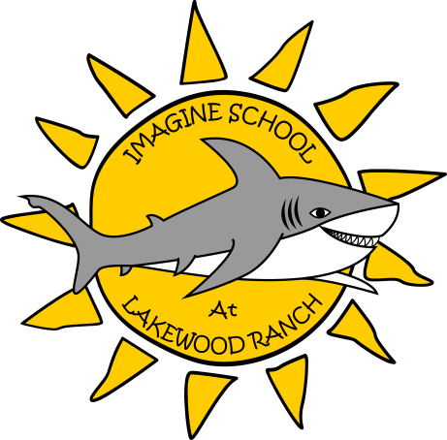
Mrs. Nickerson's Fifth Grade Supply List
2013-2014 School Year

Communal Supplies (shared by all students)
- 1 pair of student scissors (try to find the larger-sized student scissors if possible)
- 3 packs of glue sticks (at least 9 sticks)
- 1 bottle of liquid glue
- 1 box of markers
- 1 box of crayons
- 1 box of colored pencils
- 1 box of basic pencils
- 1 pack of construction paper
- 2 boxes of tissues
- 2 containers of disinfectant wipes
- 2 rolls of paper towels
- 2 packs index cards (3x5 - at least 200 total)
- 2 packages of notebook paper (loose leaf paper)
- 1 pack of regular-sized dry erase markers - last name A-L
- 1 hand sharpener with collection - last name A-L
- 2 packages of sticky notes- last name A-L
- 1 box of lunch-size zipper baggies - last name A-L
- 1 pack of skinny/fine-tip dry erase markers - last name M-Z
- 1 ream of white copy paper - last name M-Z
- 1 small stapler (in dollar section at WalMart or similar) - last name M-Z
- 1 box of gallon-size zipper baggies - last name M-Z

Individual Supplies (specifically for your child)
- 1 pack of erasers (any style) (keep one extra eraser in pencil box; leave others at home to replace as needed)
- 2 packs of pencils (These can be as fancy or plain as you want! Keep 5 pencils in pencil box; leave remainder at home to replace old pencils as needed)
- 1 pair headphones
- 5 composition books (one subject) (bring 3 to school; keep others at home for 2nd semester)
- 2 five-subject notebooks (wide ruled) (bring 1 to school; keep other at home for 2nd semester)
- 2 one-inch binders (1" only - the hard plastic ones are best, like Avery - please do not get the floppy flexible ones)
- 5-tab dividers for binder (just one set)
Individual Supplies continued
- 1 small pencil case or bag (this will be stored in your child’s backpack and only needs to house a few pencils and eraser, so this does not need to be large)
- 1 backpack (Please no wheelies or messenger-style bags. Backpacks will be stowed on the back of chairs; wheel and messenger bags do not meet this need.)
- 1 agenda and homework folder (purchased at back-to-school night or at front desk)
- 1 flash drive

Note:
Multi-color pens will be provided to each student upon the first day of school; extras will be available as ink runs out. Thus, students do not need to purchase additional pens. Students must keep the provided pen with them, along with at least 3 sharpened pencils, in their pencil cases at all times.

Wish List Items
- Recess equipment (kickball, basketball, croquet, badminton, sidewalk chalk, etc.)
- Laminating sheets for laminating machine
- Card Stock (any color, any size)
- Extra Clorox (or similar brand) wipes
- Cleaning spray
- Extra markers, crayons, or colored pencils
- Ink pads (any color)
- Full-size stapler
- Broom
- Oversized construction paper
- Craft paint, water colors, or finger paint
- Paint brushes
- Cleaning spray

